Lab Activity 01 Worksheet (24F)

Place your screenshots and answers to the questions in the spaces provided below.
(See the lab handout for the instructions and questions)

Screen shot demonstrating laptop is connected to AC Secure.
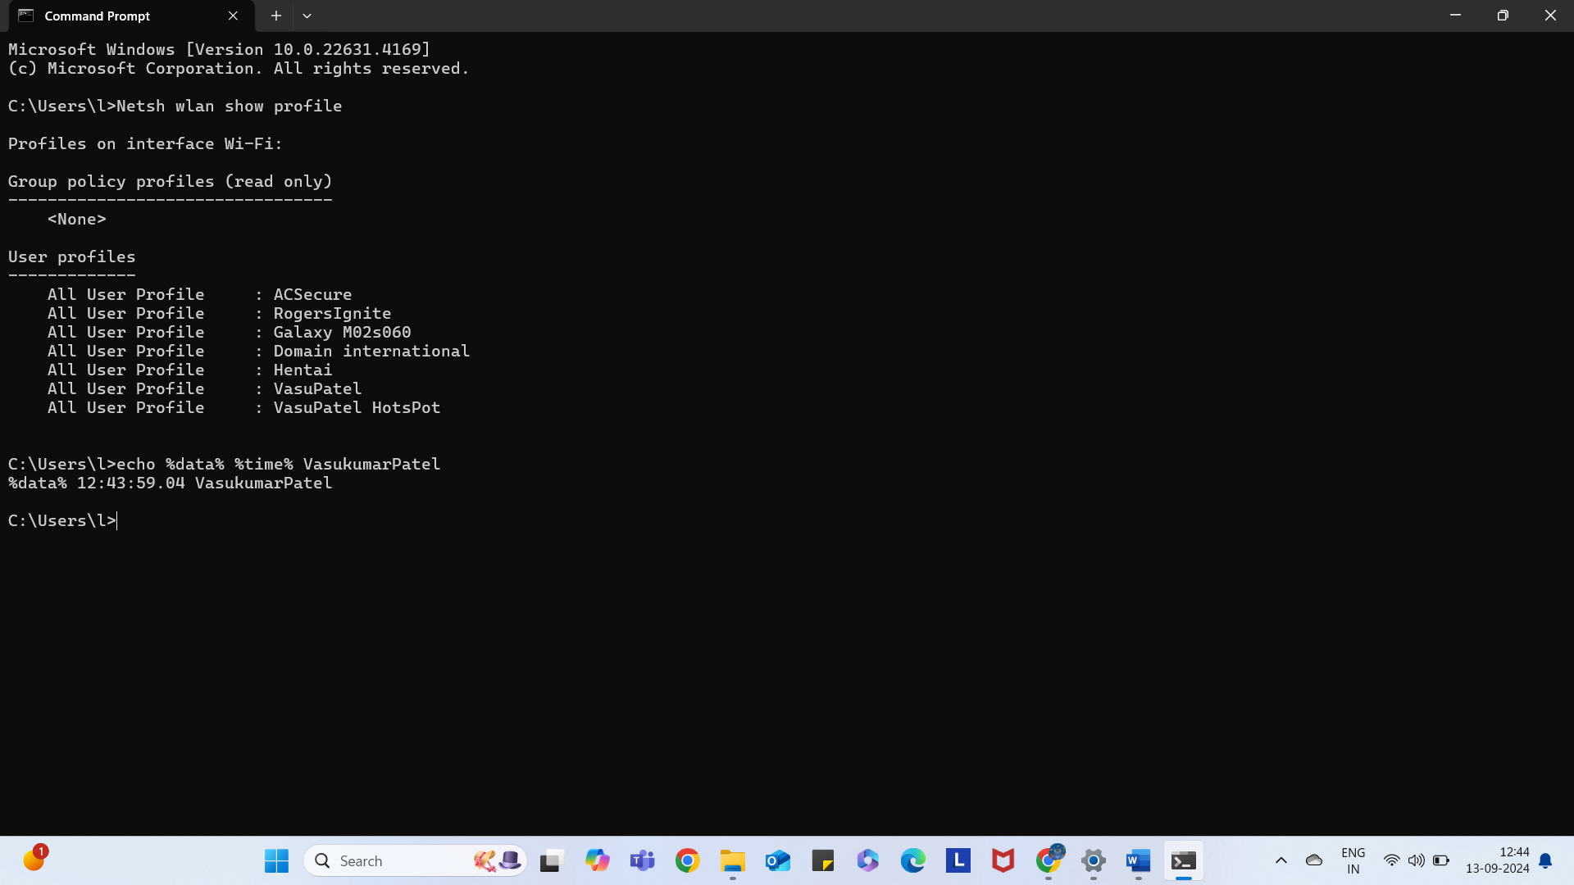
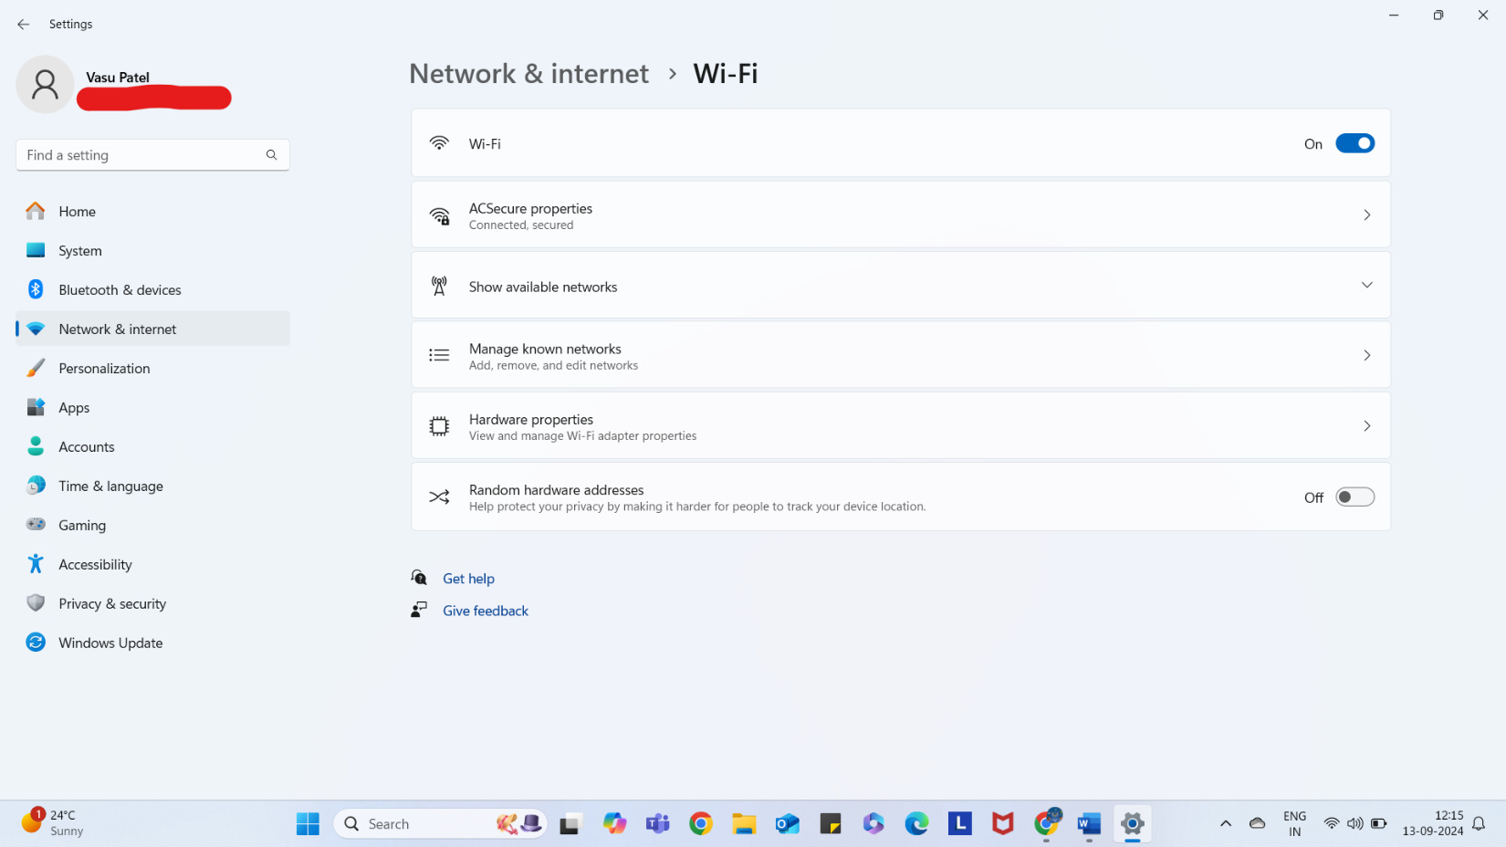

Screen shot showing Microsoft Excel is installed and running.
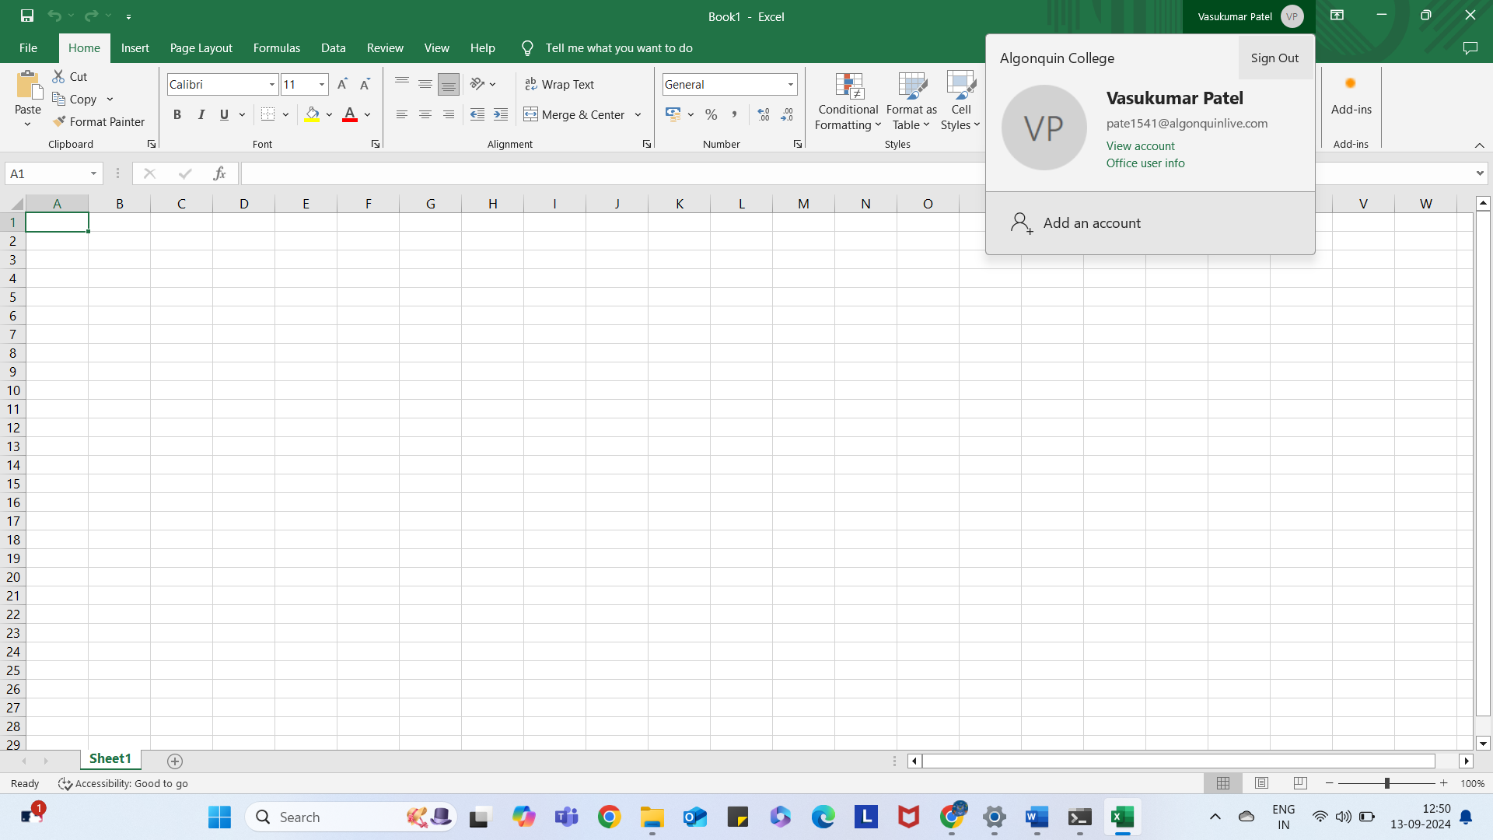

Screen shot showing Microsoft Teams is installed and running.
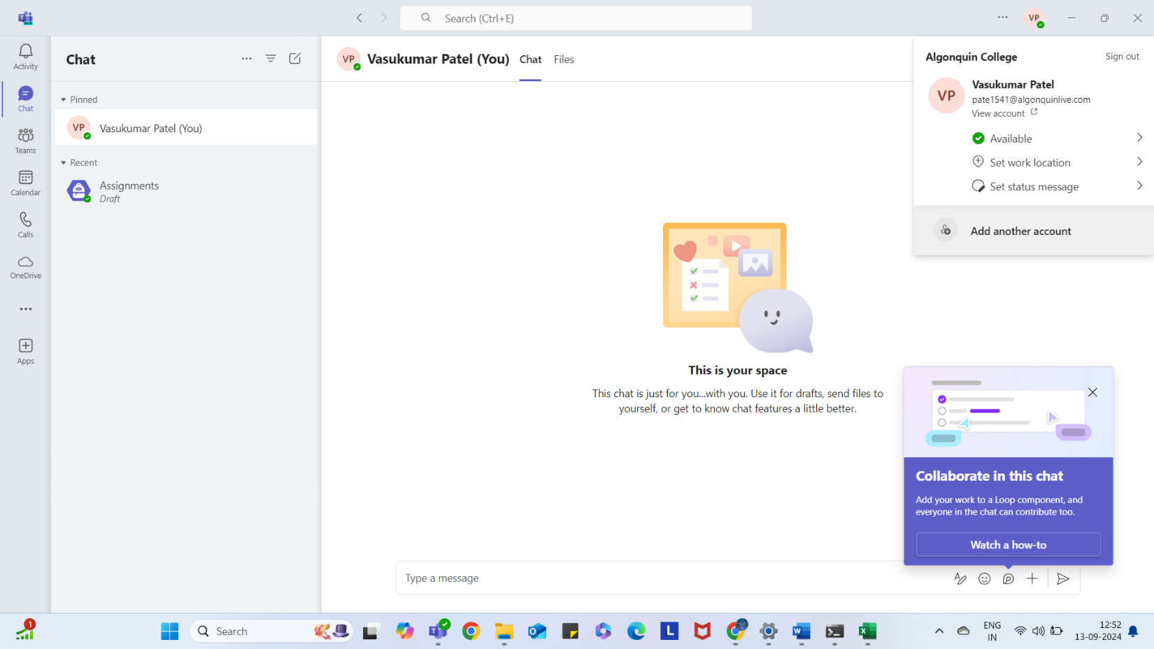

Screen shot showing Adobe Creative Cloud is installed and running.
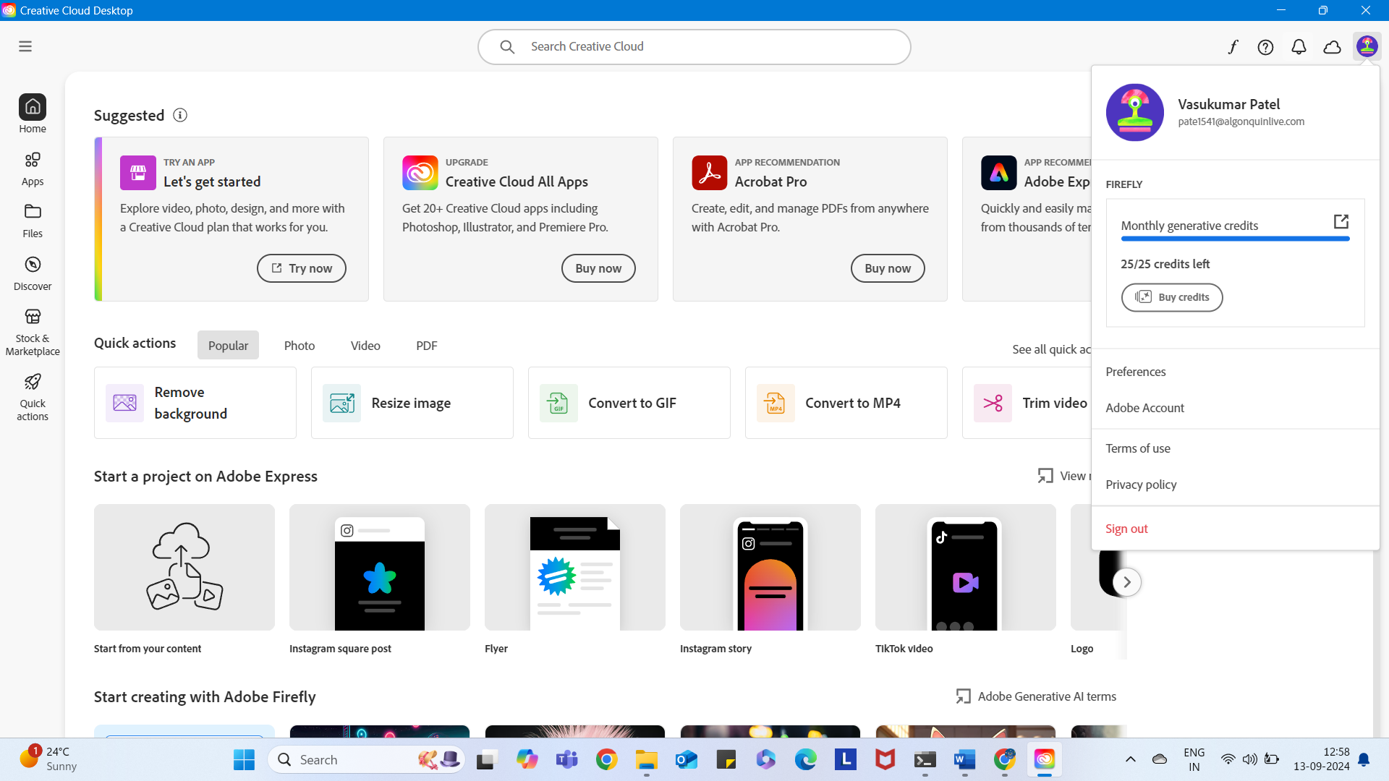

Screen shot showing Zoom is installed and running.
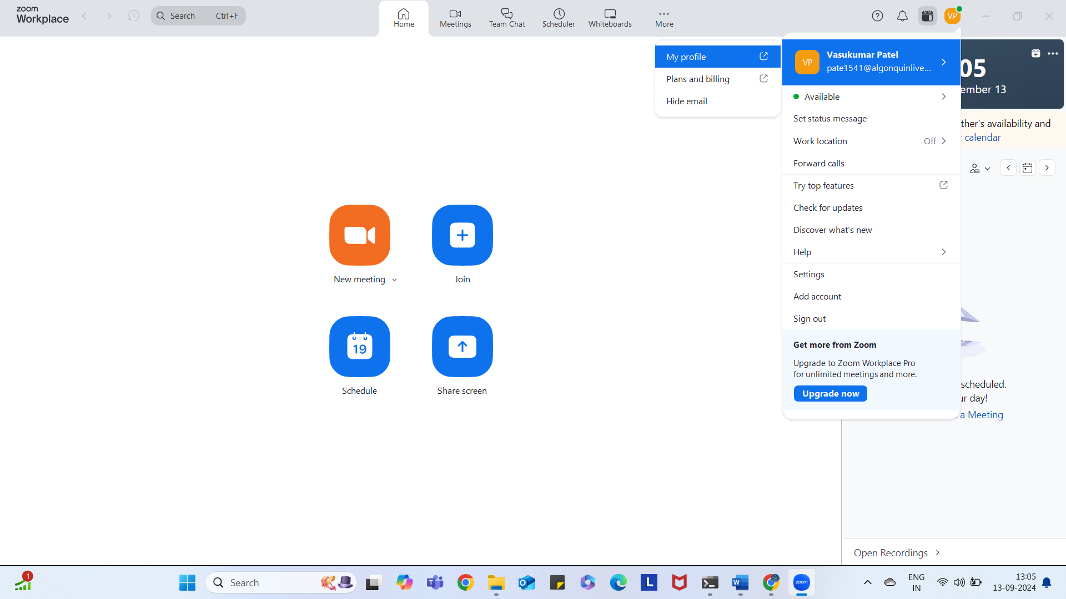

Question 1 What was the most popular year used in a password, with nearly 10 million versions used this year?
- 2010
Question 2 What is the internet’s most favorite name as a password?
- Eva

Question 3 , How long would it take a computer to crack the following password?
passwordForMeToo.
- 2 billion years

Question 4 Using website 2, determine a strong password or passphrase and record it in your worksheet.
- Vptel05@10and2005

Question 5 What is the type of license listed for adduser (you only need to answer with the acronym for the license)?
- GPL-2

Question 6 Are you permitted to install and receive updates to Ubuntu for free?
- YES, I can install and receive updates to it for free.

Question 7 Are you permitted to run a second copy of the windows operating system in a virtual machine? Or would you need to purchase an additional license?
- No, I am not permitted.

Question 8 Are you legally permitted to run MacOS Sonoma in a virtual environment on a windows laptop? Or are you only permitted to run it in a virtual environment on an Apple computer?
- No, I can not run MacOS Sonoma in a virtual environment on a windows laptop. Also, I am legally not permitted to run it in a virtual environment on an Apple Computer, but If I obtained a license for the Apple Software from the Mac App Store or through an automatic download, then I would use up to 2 extra copies of the Apple software only on their devices which must be own or control by me, and it would not use for commercial purpose in a virtual environment.

